# Assignment 1: The Solving Problem Process

**Part 1**

**Understand and Define the Problem (Analyse):**

Required to design an automated pet feeder system with the primary function of dispensing food to pets at a prescheduled time. The system should also monitor level of food consumption and alert staff of any issues, such as unconsumed food, hardware malfunctions, or empty food stock.

The system will take a scheduled time for food dispensing as an input from the user. Additionally, it will require other inputs such as the amount of food to be dispensed at feeding time, as well as a minimum amount of food that has to consumed by the pet, and the maximum allowable time for food consumption before staff need to be alerted.

The outputs for this system include triggering a servo motor to rotate, so that food can be dispensed. Additionally, the system will be required to send messages to a central database that the staff at the shelter can access. The type of message sent to the staff will depend on the outcome of the food dispensing process. If the food has been successfully dispensed and consumed by the pet, the system will send a confirmation message. Otherwise, it will send an alert message based on the issue, such as hardware problems or exceeding time and consumption thresholds. The system must also send an alert if current food stock is low and requires refilling.

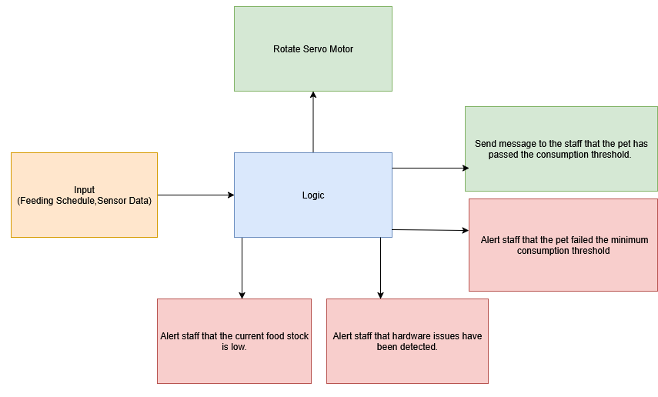The system will assume that each pet has its own feeding station, so a complex integrated design will not be necessary. Additionally, it will be assumed that each station will contain only one type of food, depending on the animal using it. Therefore, the design of the system will be limited to and not require any complex logic to differentiate between dog food and cat food. In this version of the system, users will also be limited to being able to only set a single time for feeding, which means that food dispensing will be limited to once a day.

Figure 1-Box Diagram